Assignment 2 : RUBY ON RAILS – BLOG APPLICATION

5 Action View

5.1 Comment Form
@blog.comments.build
- Automatically sets blog_id
render "blogs/show"
- Re-renders page without a new request
Strong params protect from unwanted fields
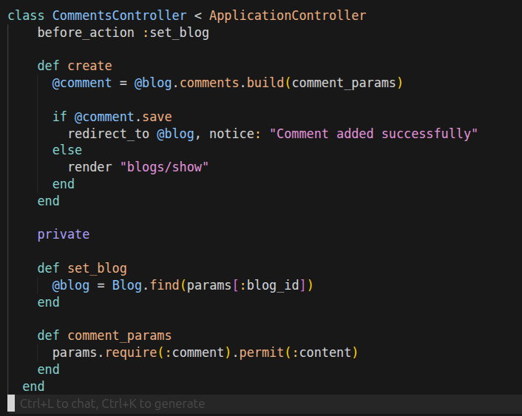

Comment Form View
Detects model state (new or persisted)
Figures out correct route:
Generates CSRF token
Generates form fields with correct names

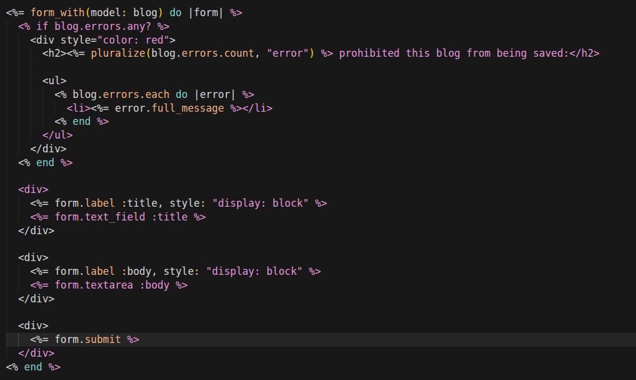

5.2 Create Layout and Render List of Comments
app/views/layouts/application.html.erb
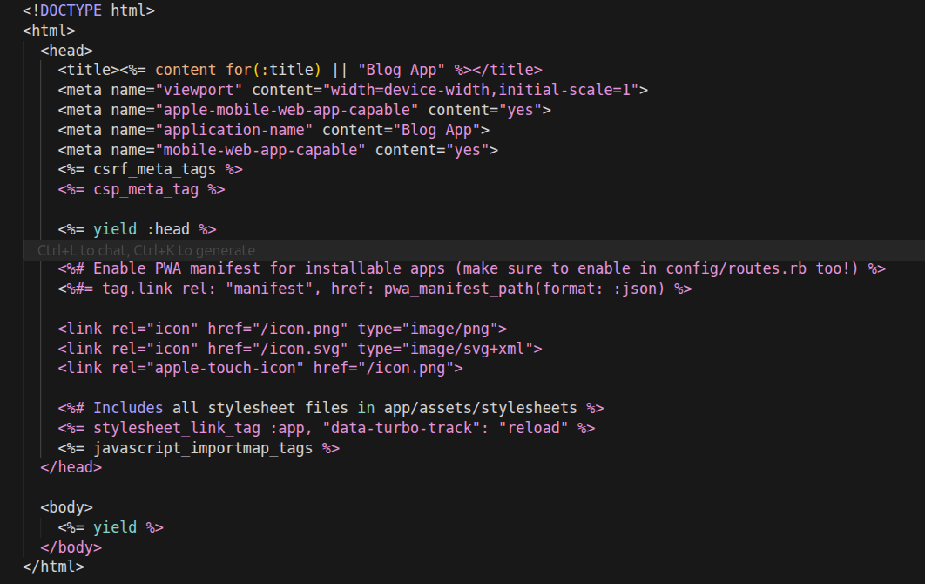

app/views/blogs/show.html.erb

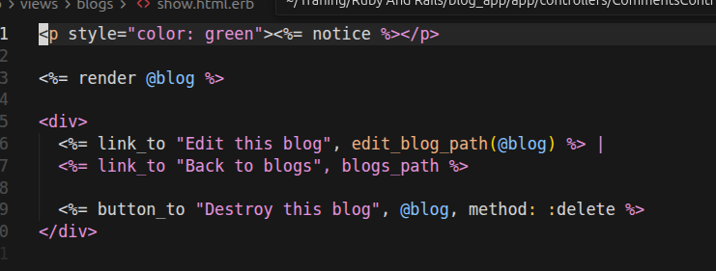

5.3 Separate Listing Page for Published & Unpublished Blogs
Detects model name → blog
Finds _blog.html.erb
Loops automatically
BlogsController

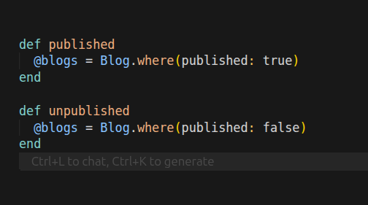

5.4 Render Options: Partials & Locals
Locals : Avoids instance variables and Cleaner, reusable views
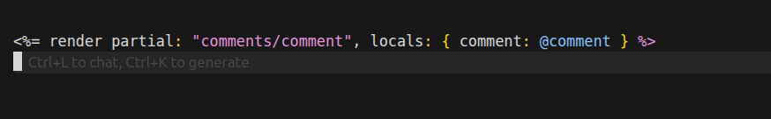

5.5 Convert ERB to HAML (Explore Only)
HAML : lease syntax , indentation based , cleaner templates

5.6 How Ruby is Embedded in Templates

Tag | Meaning
<% %> | Ruby logic
<%= %> | Output
<%# %> | Comment

5.7 Explore form_with Options
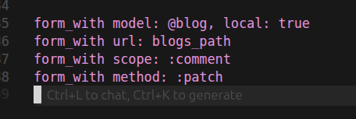

6 CORE & SUPPORTING COMPONENTS

6.1 SERIALIZERS
When building APIs, returning models directly leads to inconsistent JSON
A serializer is a presenter for JSON.

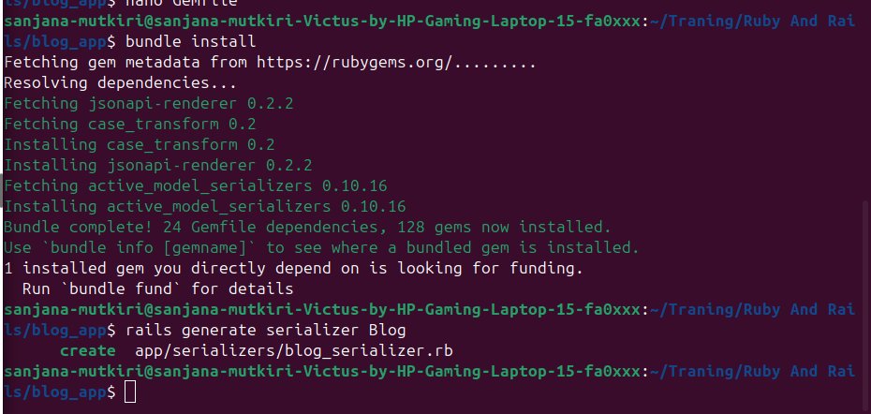

6.2 SERVICE OBJECT
It is plain Ruby class encapsulates one business action

6.3 ACTIVEJOB

A framework for background jobs that:
- Provides a unified API
- Works with Sidekiq, Resque, DelayedJob
- Decouples job logic from queue backend
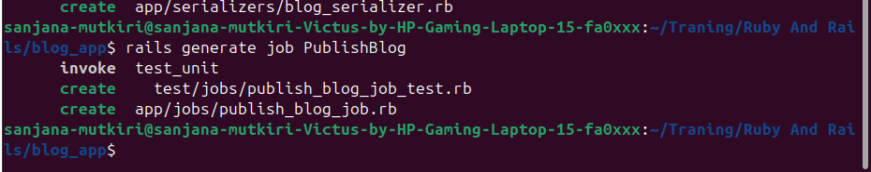

6.4 RAKE TASKS

Some tasks:
- Don’t belong to controllers
- Need CLI execution
- Are admin / maintenance jobs
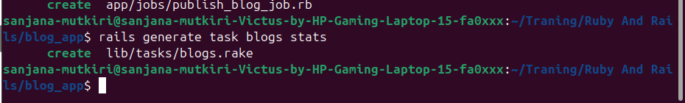

6.5 BENCHMARKING
Benchmark detect slow queries and includes N+1 quires

7 TESTING & API DOCUMENTATION

7.1 Setup Testing Gems
A testing framework replacing Rails’ default Minitest is rspec-rails
(You describe what the system should do and Not how it does it)
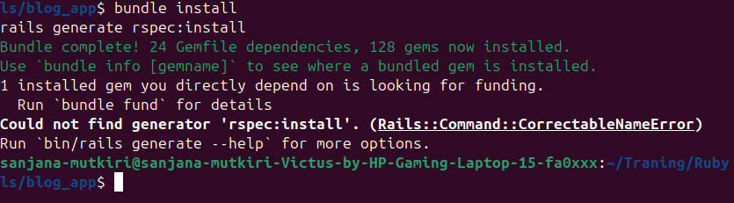

7.2 MODEL SPECS

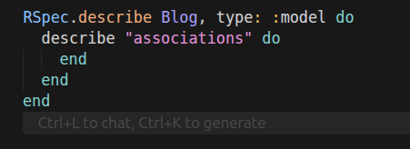

7.3 REQUEST SPECS

Catch routing errors
Validate API contracts
Ensure serialization works
Prevent breaking frontend

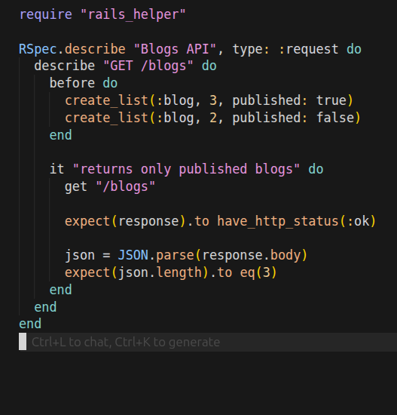

8 Common Mistakes

8.1 N+1 Queries

Happens when you load objects and then repeatedly query an association in a loop.
Called N+1 because:
- First query → load N parent objects
- Then 1 query per object → load associated data
Fix
A tool to detect N+1 queries in development
Alerts you if your code is triggering multiple queries for associations

8.2 find vs pluck
find in Rails

Returns an ActiveRecord object
All columns are loaded by default

pluck in Rails

Returns an array of raw values,
No ActiveRecord objects are instantiated

